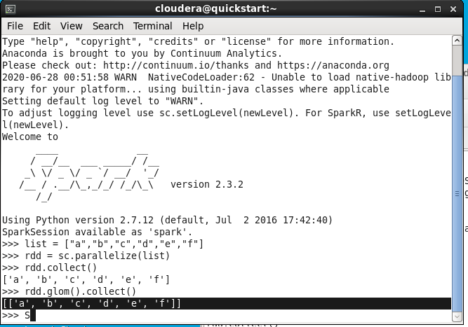

This is coming in 1 partition as we have allocated 1 CPU to VM

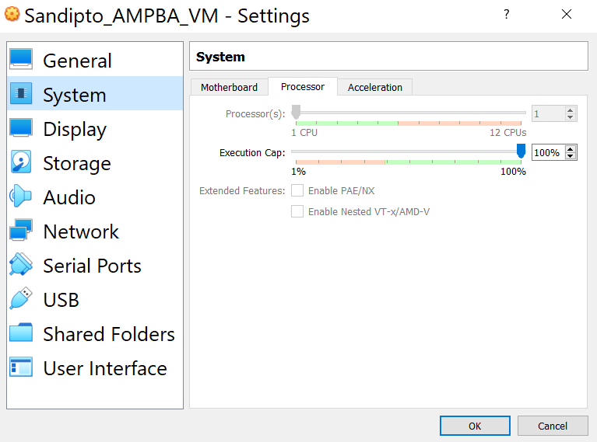

# Taking things on own hands

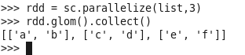

But we have given 1 machine so creating partitions is nonsensical.